Light Amplification
In the last lecture we showed that we could get laser action if we can raise the energy density in our laser material sufficiently high. This can be achieved if we use a cavity to bounce the light already produced back into the material until the light density is sufficiently high that the stimulated emission term is greater than that for spontaneous emission.
However for this to be the case we need to ensure that as light passes through the material there is a net increase in its intensity.
Let us consider a slab of material of unit cross-sectional area, and thickness, dx:

If this small volume is immersed in the optical beam then there will be a change in the light intensity, I, by some amount dI.

Using the two energy level system described in the last lecture then we have the density of electrons in E₂ being n₂ and the similarly being n₁ in E₁. As before the beam can be assumed to consist of photons of energy hν₂₁ = E₂ - E₁.
In this example we shall assume that the spontaneous emission rate is very low, and can be neglected.
As the photons travel along our piece of material they two things can happen to them: they can be absorbed, or they can stimulated other photons to be emitted:
The number of photons absorbed/unit time in our thin slab will be: 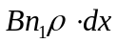
Similarly the number of photons stimulated to emit/unit time will be: 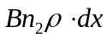
Thus the net number of photons stimulated to emit in dx per unit time 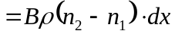
Therefore the net energy generated/unit time 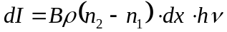
The energy density is simply the light intensity divided by the light velocity in the material: 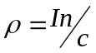
This gives a simple differential equation: 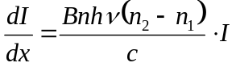
So what does this equation mean?

It will have a solution given by:

Let us apply a boundary condition of I = I₀ at x = 0
There are three possible scenarios:
i. 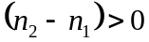

ii. 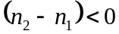

iii. 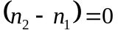

We want light to built up in the cavity, (where from last time we said we had our laser material sandwiched between two mirrors:

This can only happen IF 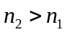. The question is therefore how can we make this occur?
Before we do this let us consider the laser cavity we introduced at the end of last lecture:

As can be seen on the RHS as the light bounces back and forth the intensity (or energy density) of the light increases with each bounce. No matter how small I₀ was initially it will build up to make 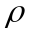 large; if of course we can satisfy the condition that .
However, as we know that 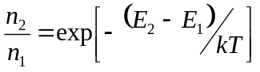 which means at room temperature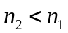, which is as we should expect. This means that normally materials are ABSORBING.
To get a laser we need to INVERT the population of electrons – that is make .
To do this we can excite the material, or ‘pump’ it.
There are two methods of pumping:
- ELECTRICAL PUMPING
- OPTICAL PUMPING.
Semiconductor lasers are of course electrically pumped, but before going into that area let use briefly consider the optical pump case for our two level system

In ≡^{m} , and to change this let us pump the system hard with photons. This will cause electrons to be pushed up into E₂. However as n₂ increases then so will the rate of stimulated emission, so we will have some loss. The net rate of absorption can be given by:
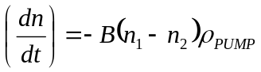
Where 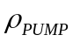 is the electromagnetic energy density of the pump light.
The key point is that as the pump continues 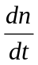 will fall as 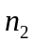increases until 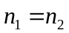. At this point there is no more net absorption.
The material is pumped to transparency (or “BLEACHED”) but we can go no further as at this point the probability of an electron absorbing a photon is the same as it being stimulated to fall back down again emitting a photon.
It is impossible to invert the population of this two level system.
This problem can be overcome by increasing the number of levels to three or four:

In this case we can get an inversion between the upper and lower levels. The four level laser is an effective way to pump a material as the lower energy state of the laser has a low density of electrons. This makes it easier to have, and to keep a population inversion.

There are many NON-SEMICONDUCTOR lasers. However as Semiconductor lasers become more efficient and better designed the markets these lasers can address become smaller and smaller. The main lasers are
Solid State Lasers: Crystals doped with some light emitting impurity (Nd:YAG is the most famous example)
Gas Lasers: He-Ne is red, Ar ion is green. One of the most famous is CO₂.
These lasers have applications where semiconductor lasers find things difficult: Very High Powers, Wavelength Stability, Some solid state lasers allow the wavelength to be controllably changed over a wide range. In addition to being extremely high power, CO₂ lasers emit around 10 μm, which there is no semiconductor analogue.

QUESTION: Can we optically pump a semiconductor material and make it lase?

